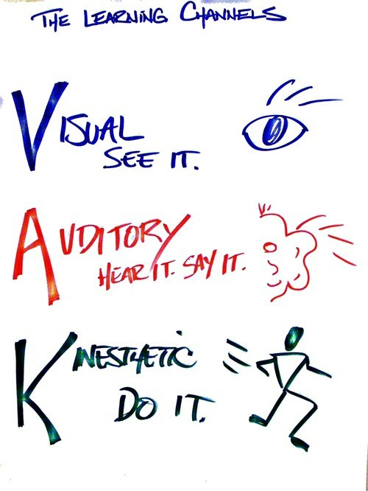Identifying Your Learning Style

For these questions, choose the first answer that comes to your mind. Do not spend too much time thinking about any question. Underline the correct answer.

1. Which way would you rather learn how a computer works?

a. watching a video about it

b. Listening to someone explain it

c. Taking the computer apart and trying to figure it out for yourself

2. When you are not sure how to spell a word, which of these are you most likely to do?

a. write it out to see if it looks right b. sound it out
c. write it out to sense how it feels

3. If you were at a party, what would you be most likely to remember the next day?

a. the faces of the people there, but not their names b. the names but not the faces
c. the things you did and said while you were there

4. How would you rather study for a test?

a. read notes, read headings in a book, look at diagrams and illustrations b. have someone ask you questions, or repeat facts silently to yourself
c. write notes out on index cards and make models or diagrams

5. What do you find most distracting when you are trying to concentrate?

a. visual distractions b. noises
c. other sensations like hunger, tight shoes, or worry

6. How do you prefer to solve a problem?

a. make a list, organize the steps, and check them off as they are done b. make a few phone calls and talk to friends or experts
c. make a model of the problem or walk through the steps in your mind

7. Which are you most likely to do while standing in a long line at the movies?

a. look at the posters advertising other movies b. talk to the person next to you
c. tap your foot or move around in some other way

8. You have just entered a science museum.

What would you do first?

a. find a map showing the locations of the various exhibits b. talk to a museum guide and ask about exhibits
c. go into the first exhibit that looks interesting and read directions later

9. When you are happy, what are you most likely to do?

a. grin

b. shout with joy

c. an exercise class

10. Which would you rather go to?

a. an art class

b. a music class

c. an exercise cla ss

11. Which of these do you do when you listen to music?

a. daydream (see images that go with the music)

b. hum along

c. move with the music, tap your foot, etc.
12. How would you rather tell a story?

a. write it

b. tell it out loud c. act it out
13. Which kind of restaurant would you rather not go to?

a. one with the lights too bright b. one with the music too loud
c. one with uncomfortable chairs

Total all you’re a’s, b’s and c’s

• If you scored mostly a’s, you have a visual learning style. You learn by seeing and looking.

• If you scored mostly b’s, you have an auditory learning style. You learn by hearing and listening.

• If you had mostly c’s you have a kinaesthetic learning style. You learn by touching and doing.

• If you picked two letters about the same number of times, you depend on both of those learning styles.

My Results (Aviel):
A= 5
B= 4
C= 4

Requirement:

1. Determine your learning styles by following the directions above.

I am a Visual Learner but I also learn from hearing, listening, touching and doing things as well.

2. Report on your findings and support this with evidence as it applies to you.

I am a visual learner and it shows when I learn because I don’t focus as well when the person isn’t showing it to us visually. Visually learning is easier because I can see what the teacher does and I can copy and learn.

